* Virtual Office Service
* Receptionist
* State of the Art Offices
* Full-time management team

UBC Serviced Offices, Tetbury Road  
Cirencester GL7 6JJ

SERVICED OFFICES TO LET

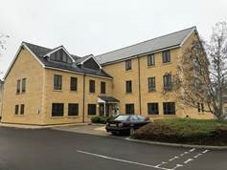



4 Sidings Court, Doncaster DN4 5NU

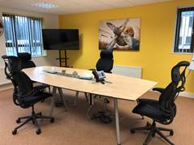

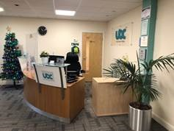

**LOCATION**Cirencester Office Park is a modern scheme of three significant office properties located approximately ½ mile to the north-west of Cirencester town centre fronting the A429 Tetbury Road.

Cirencester us situated equidistant between the M5 to the north and M4 to the south. Gloucester and Cheltenham are 12 miles and Swindon is 14 miles to the south via the A417 / A419 which are the main dual carriage ways.

Kemble railway station is only 3 miles away and provides direct access to London Paddington in 75 minutes and Swindon or Cheltenham in 20 minutes.

**DESCRIPTION**UBC Cirencester Office Park has 3 floors of Serviced Offices of this Cotswold stone office building under a pitched slate roof.

Finished to a high standard with good quality partitioning providing cellular offices, there is a suspended ceiling incorporating recessed lighting as well as raised floors with floor boxes.

Allocated car parking spaces are available.

Benefits

* Fixed Costs and Low Risk
* Meeting Rooms
* State of the Art Offices
* Virtual Office Service
* Flexible workspace to rent
* Service
* Modern & Professional
* Full-time management team
* Receptionist
* Business Support

**RENT**On Application

**SERVICES**None of the services have been tested and interested parties are advised to satisfy themselves in this regard.

**ENERGY PERFORMANCE CERTIFICATE (EPC)**TBC

**RATING**The adopted rateable value is not known not available or not applicable unless specified.

**VALUE ADDED TAX**Unless otherwise stated, all rents and sale prices are quoted exclusive of VAT. Any prospective lessee or purchaser must independently satisfy himself or herself as to the incidence of VAT in respect of any transaction.

**INSPECTIONS & FURTHER INFORMATION**Viewings strictly by prior appointment with the agents:

Andrew Seale

Barnsdales - Chartered Surveyors

Tel: 01285 657 944

andrew@barnsdales.co.uk

**Disclaimer**Misrepresentation Act 1967: Barnsdales for itself and for the vendor(s) or lessor(s) of this property whose agent it is give notice that:   
1. These particulars do not constitute any part of an offer or contract. 2. None of the statements contained in these particulars as to the property(s) are to be relied on as statements or representations of fact. 3. Any intending purchaser must satisfy himself/herself by inspection or otherwise as to the correctness of each of the statements contained within these particulars. 4. The vendor(s) or lessor(s) do not make or give and neither Barnsdales nor any person in its employment has any authority to make or give any representation or warranty whatsoever in relation to the property. 5. None of the building’s services or service installations (whether these be the specific responsibility of the freeholder, lessor or lessee) have been tested and are not warranted to be in safe and working order.   
Finance Act 1989: Unless otherwise stated all prices and rents are quoted exclusive of VAT.   
Consumer Protection from Unfair Trading Regulations 2008 and Business Protection from Misleading Marketing Regulations 2008: Every reasonable effort has been made by Barnsdales to ensure accuracy and to check the facts contained within these particulars are complete. Interested parties are strongly advised to take appropriate steps to verify by independent inspection or enquiry all information for themselves and to take appropriate professional advice.